Personalized Interventions Plan for GT
Student Name | CogAT Scores | Ability Profile
 | ____ V ____Q ____NV
The CogAT generates an Ability Profile to summarize how each student learns, excels and/or struggles based on their areas of strengths.
- Examine your student lists to determine HOW your student qualified to be in your class.
- What are their areas of strength? CogAT Profile Report
- Do they have relative weakness in outlier scores? (look for C or E coding in their Ability Profiles)
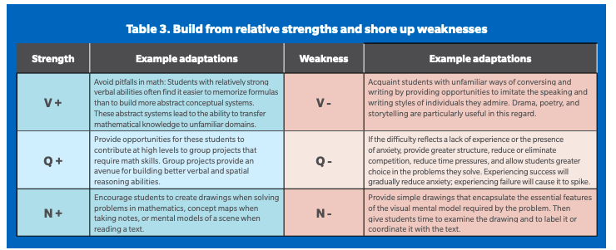
- BE INTENTIONAL with the data:
My observations as related to these scores:
Strengths | Weaknesses
Starting Point of Intervention Options:
Domain | - STRENGTH AREA | - WEAKNESS AREA | Depth & Complexity
V | Socratic Seminar, Debate, philosophical chairs, podcasting, | Fish bowl, Socratic Seminar (with word banks), role play, storytelling, monologues, readers theater, philosophical chairs (with talking chips) | Big Idea  LOD  Multiple Perspectives  Details
Q | Surveys & Graphs  Data  Computer based activities/products | Red Ink it (Find the error) | Trends  Changes over time  Details
NV | Graphic Presentations - charts, sketchbook notes, timelines, diagrams, flow charts, maps, venn diagrams, concentric circles, mind maps  Mixed media products  Podcasting, PSAs | Foldables  Interactive notebooks  Graphic organizers | Rules  Across the Disciplines  Ethics  Changes over time  Unanswered questions  (J Taylor Graphic Organizers)
ALPS/Richardson ISD 2022 WORK IN PROGRESS

