Advanced Growth Plan using MAP Data
Student Name | MAP Scores | Growth Above the Mean | Quadrant Chart
 | Math RIT____  Reading RIT ____ | Math _____  Reading ____
The NWEA MAP test allows educators to compare achievement status—and changes in achievement status (growth)—to students’ performance in the same grade at a comparable stage of the school year. This empowers teachers to plan instruction for individual students.
Reports to Help Monitor Growth:
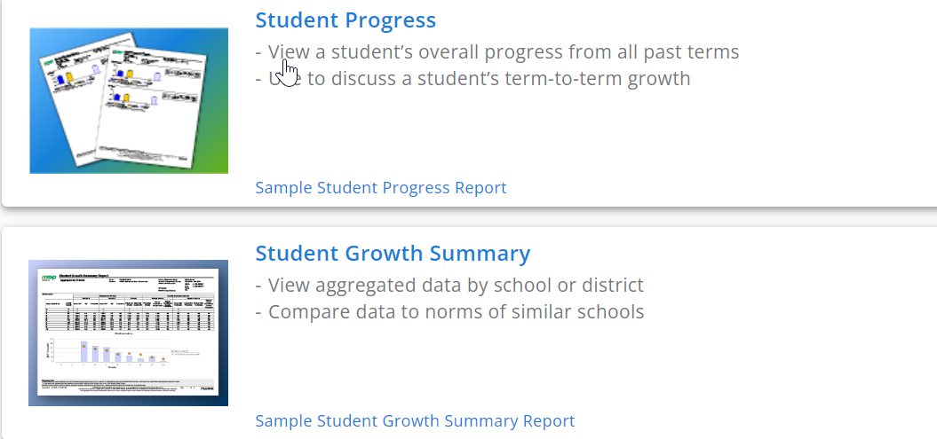

Reports to Help Plan Instruction:
https://teach.mapnwea.org/impl/MAPGrowthComparativeData.pdf https://teach.mapnwea.org/assist/doc/QRM2_MAP_Reports_Summary_QuickRef.pdf

My Observations from these reports:

Strengths | Weaknesses

CCMR Indicators - Projected Success
 | SAT | ACT
ELA/Rdg
Math

